* High Income Areas
  + Scottsdale North, AZ Urban Cluster
  + Union township (Porter County), IN Urban Cluster
  + Key Biscayne, FL Urban Cluster
  + Rancho Murieta, CA Urban Cluster
  + Aspen, CO Urban Cluster
  + Vail, CO Urban Cluster
  + Park City, UT Urban Cluster
  + Half Moon Bay, CA Urban Cluster
  + Hightstown, NJ Urbanized Area
  + Bridgeport—Stamford, CT—NY
  + Washington-Arlington-Alexandria, D.C-Virginia-Maryland MSA
  + Boston–Worcester–Lawrence, Massachusetts–New Hampshire–Maine–Connecticut CMSA
  + San Jose-Santa Clara-Sunnyvale, California
  + Minneapolis-St. Paul-Bloomington
  + Honolulu, Hawaii
* Medium Income Areas
  + Chesterbrook, Pennsylvania (Philadelphia)
  + Holly Hills, Colorado (Denver Small)
  + Lumberton, North Carolina
  + Penn Wynne, Pennsylvania (Philadelphia)
  + Carmel, Indiana
  + Inverness, Florida
  + Blacksburg, VA
  + Charleston, West Virginia
  + Brookline, Massachusetts (Boston)
  + Okemos, Michigan (Lansing)
  + Los Alamos, New Mexico
  + Ardmore, Pennsylvania (Philadelphia)
  + Clarendon Hills, Illinois (Chicago)
  + Richmond Heights, Missouri (St. Louis)
  + Morrisville, North Carolina (Raleigh)
  + Stone Ridge, Virginia
  + Swarthmore, Pennsylvania (Philadelphia)
  + Clayton, Missouri (St. Louis)
  + South Kensington, Maryland
* Low-Income Areas
  + Detroit, Michigan
  + Cleveland, Ohio
  + Cincinnati, Ohio
  + Miami, Florida
  + Fresno, California
  + Buffalo, New York
  + Newark, New Jersey
  + Toledo, Ohio
  + Milwaukee, Wisconsin
  + St. Louis, Missouri
  + Baldwin, Michigan
  + Franklin, Georgia
  + Highland Park, Michigan
  + Warrenton, Georgia
  + Selma, Alabama
  + South Tucson, Arizona
  + Clearlake, California
  + Willimantic, Connecticut
  + Brownsville, Florida
  + Rupert, Idaho
  + Floyd/Christiansburg, VA

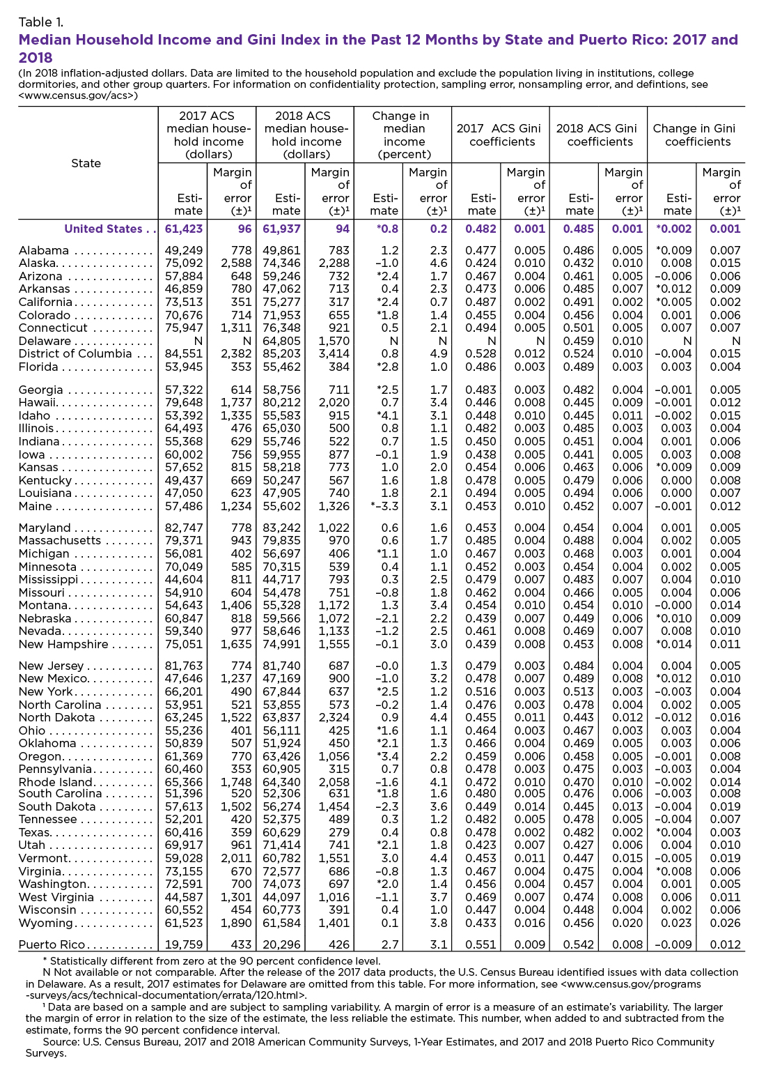

* U.S. Census Bureau. “U.S. Median Household Income Up in 2018 From 2017.” *The United States Census Bureau*, 29 Oct. 2019, [www.census.gov/library/stories/2019/09/us-median-household-income-up-in-2018-from-2017.html](http://www.census.gov/library/stories/2019/09/us-median-household-income-up-in-2018-from-2017.html)
* <https://www.niche.com/places-to-live/search/best-suburbs/>.
* https://www.niche.com/places-to-live/search/best-suburbs/?costOfLiving=affordable&costOfLiving=expensive